REASONING IN SCIENCE
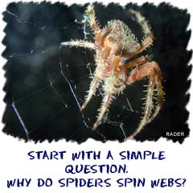
Learning about the scientific method is almost like saying that you are learning how to learn. You see, the scientific method is the way scientists learn and study the world around them. It can be used to study anything from a leaf to a dog to the entire Universe.
The basis of the scientific method is asking questions and then trying to come up with the answers. You could ask, "Why do dogs and cats have hair?" One answer might be that it keeps them warm. BOOM! It's the scientific method in action. (OK, settle down.)

QUESTIONS AND ANSWERS
Just about everything starts with a question. Usually, scientists come up with questions by looking at the world around them. "Hey look! What's that?" See that squiggly thing at the end of the sentence? A question has been born.
So you've got a scientist. When scientists see something they don't understand they have some huge urge to answer questions and discover new things. It's just one of those scientist personality traits. The trick is that you have to be able to offer some evidence that confirms every answer you give. If you can't test your answer, other scientists can't test it to see if you were right or not.
As more questions are asked, scientists work hard and come up with a bunch of answers. Then it is time to organize. One of the cool things about science is that other scientists can learn things from what has already been established. They don't have to go out and test everything again and again. That's what makes science special: it builds on what has been learned before.
This process allows the world to advance, evolve, and grow. All of today's advancements are based on the achievements of scientists who already did great work. Think about it this way: you will never have to show that water (H₂O) is made up of one oxygen (O) and two hydrogen (H) atoms. Many scientists before you have confirmed that fact. It will be your job as a new scientist to take that knowledge and use it in your new experiments.

EXPERIMENTAL EVIDENCE
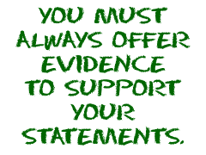
Experimental evidence is what makes all of the observations and answers in science valid (truthful or confirmed). The history of evidence and validations show that the original statements were correct and accurate. It sounds like a simple idea, but it is the basis of all science. Statements must be confirmed with loads of evidence. Enough said.
Scientists start with observations and then make a hypothesis (a guess), and then the fun begins. They must then prove their hypothesis with trials and tests that show why their data and results are correct. They must use controls, which are quantitative (based on values and figures, not emotions). Science needs both ideas (the hypothesis) and facts (the quantitative results) to move forward. Scientists can then examine their data and develop newer ideas. This process will lead to more observation and refinement of hypotheses.

THE WHOLE PROCESS
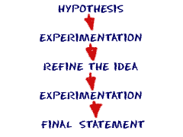
There are different terms used to describe scientific ideas based on the amount of confirmed experimental evidence.
Hypothesis
- a statement that uses a few observations
- an idea based on observations without experimental evidence
Theory
- uses many observations and has loads of experimental evidence
- can be applied to unrelated facts and new relationships
- flexible enough to be modified if new data/evidence introduced
Law
- stands the test of time, often without change
- experimentally confirmed over and over
- can create true predictions for different situations
- has uniformity and is universal
You may also hear about the term "model." A model is a scientific statement that has some experimental validity or is a scientific concept that is only accurate under limited situations. Models do not work or apply under all situations in all environments. They are not universal ideas like a law or theory.

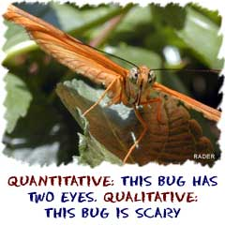
Logic has you thinking with reason and arguments (statements). Scientists use logic because it shows the relationships between the parts of an idea and the whole idea. Therefore, if you use logic, you can see a relationship between a few trees and the entire forest. On the other hand, if we talk about biology, if you understand how animals interact with each other then you are able to better understand the whole ecosystem.

LOGICAL REASONING
The scientific method is a rational, logical thought process that is used to figure out facts and truths. All of the answers must be able to be proved. When someone comes up and says, "Hey! I figured out the answer!" the other scientists can get together, see what the new person did, and then they repeat the procedures. If they come up with the same answer, everybody is happy. If the answer is different, someone did something wrong and everyone starts all over again.
There are no opinions that are considered scientific laws. To scientists, the truth is something that is quantitative. Quantitative statements are ones that can be proved through experiments. When someone has an opinion, or an idea that can't be proved directly, they call it a qualitative argument.

DEDUCTIVE REASONING
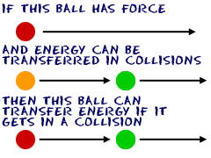
Deductive reasoning has you starting with information or an idea that is called a premise. Eventually you come up with conclusions that are based on your original premise. Sherlock Holmes, that detective guy from the books, uses deductive reasoning to solve mysteries. Think of it this way:
(1) If this happens...
(2) and this happens...
(3) then you can come to this conclusion. If the premises are true, then your conclusion should also be true.

INDUCTIVE REASONING
Inductive reasoning works in the opposite direction. You start by having a number of observations. "I see that." "That happens here." "I believe that this will happen just like the others because the circumstance is similar."
It is a process in two parts. First you start with specifics and come up with a theory. That's deductive. When you apply that theory to new areas, it is inductive reasoning. You organize data into categories and say, "What do these have in common?"
There is a problem with inductive reasoning: your conclusions have more information than the facts you use. You start with dozens of observed examples, take an inductive leap, and assume millions of possible examples. If the conclusion is true, then new premises and assumptions are true.

LOGIC TOOK A LONG TIME TO REFINE
We don't want you to think all of these theories of logic happened overnight. Logic and reasoning have evolved over thousands of years. The ideas are still the same, but the methods have been documented and examined. Scientists are now able to take the ideas they have developed and apply them to new computer systems. You may have heard of Artificial Intelligence and fuzzy logic. Computers that use those methods of analysis are doing amazing things.
Back in the beginning, there was a guy in ancient Greece who started writing down a lot of these ideas. His name was Aristotle. He didn't invent this way of thinking; people had been using logic forever. Aristotle was just the first guy to start writing down the ideas and rules of what makes something a logical process.

SYLLOGISTIC REASONING
Aristotle described something called syllogistic reasoning. A syllogism is an argument. Arguments are statements used when you describe things with logic. There are four different types of syllogistic arguments.
(1) All A's are B's (universal affirmative)
(2) No A's are B's (universal negative)
(3) Some A's are B's (particular affirmative)
(4) Some A's are not B's (particular negative)
If you look at these statements, they all start with the basic idea that A (a thing) exists. You can't make any of those four statements if A does not exist or is not true.
As logic has evolved, modern logic has changed the first statement to say, "If something is A, then it is also B." It can get a bit confusing. For many scientists, logic is a completely separate branch of science and philosophy. Don't worry if you don't get it from our quick overview. Try this example.
(1) All cats are animals (universal affirmative)
(2) No cats are plants (universal negative)
(3) Some animals are cats (particular affirmative)
(4) Some animals are not cats (particular negative)
Each of these arguments (statements) is true and they all are examples of the four different types of syllogistic arguments.

